  - Meeting minute Agenda and minutes Template:

Student ID: | CTI20221062
Student Name: | Leonardo Matias Ciarcia
Meeting for scenario
Meeting Agenda and Minutes template: ICTNPL413, ICTNWK561, ICTTEN622, and ICTNWK612
Date/Time: | 19/08/2025
Location: | CTI, Level 8, Room number 04, 333 Adelaide St, Brisbane, QLD 4000
Chairperson: | Dijo
Meeting Attendees:  Full names and roles | - Insert the group photo taken during the meeting and the physically signed attendance sheet here.  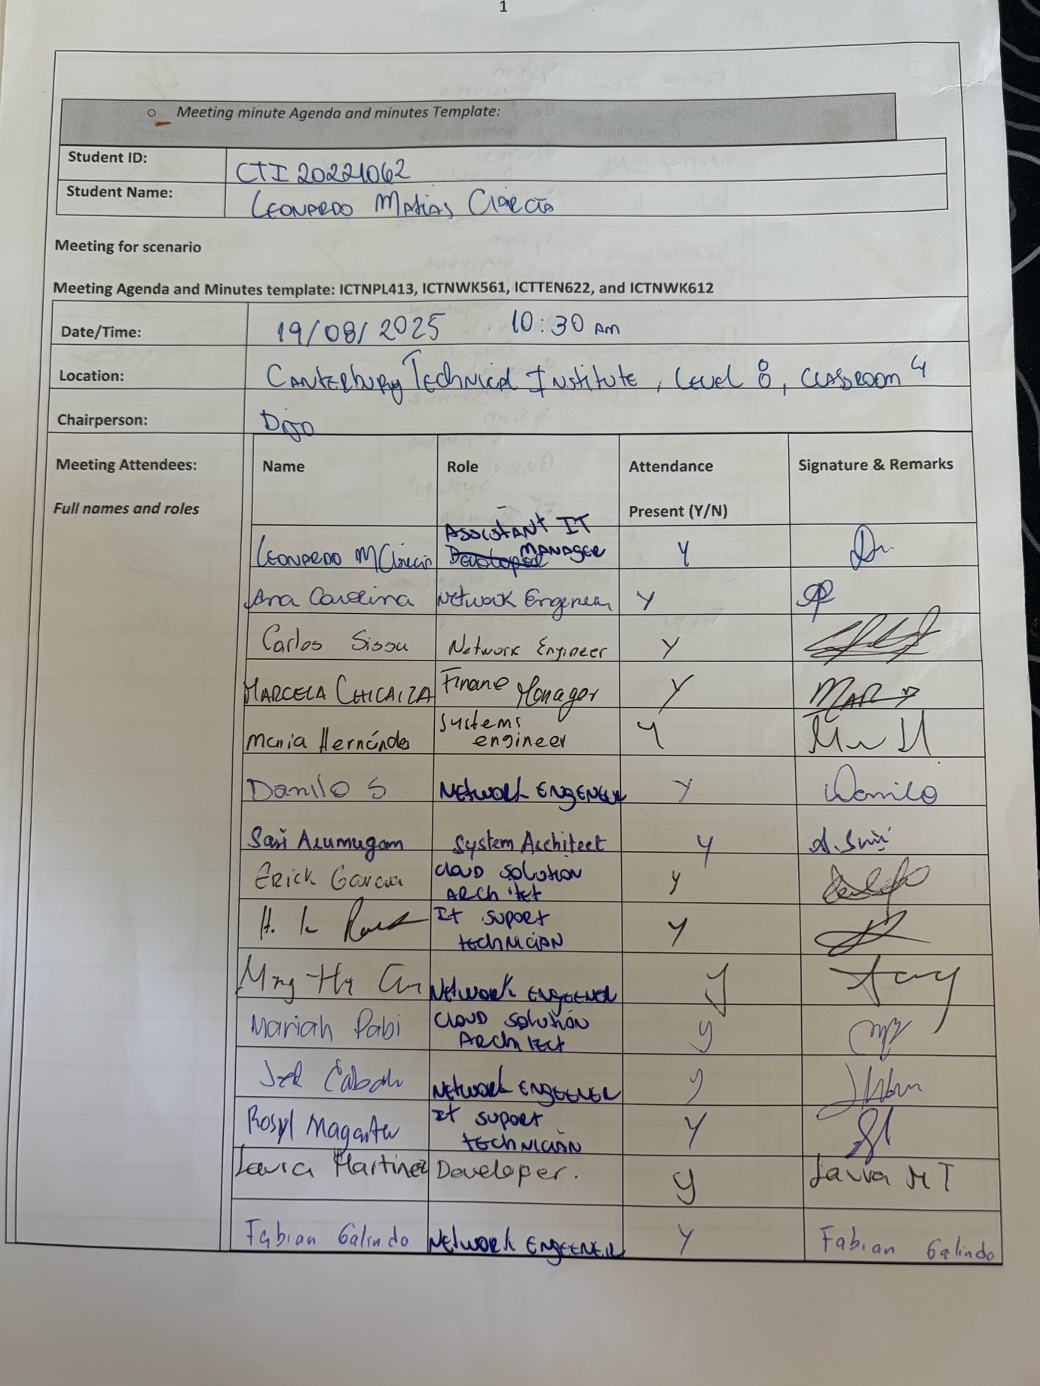  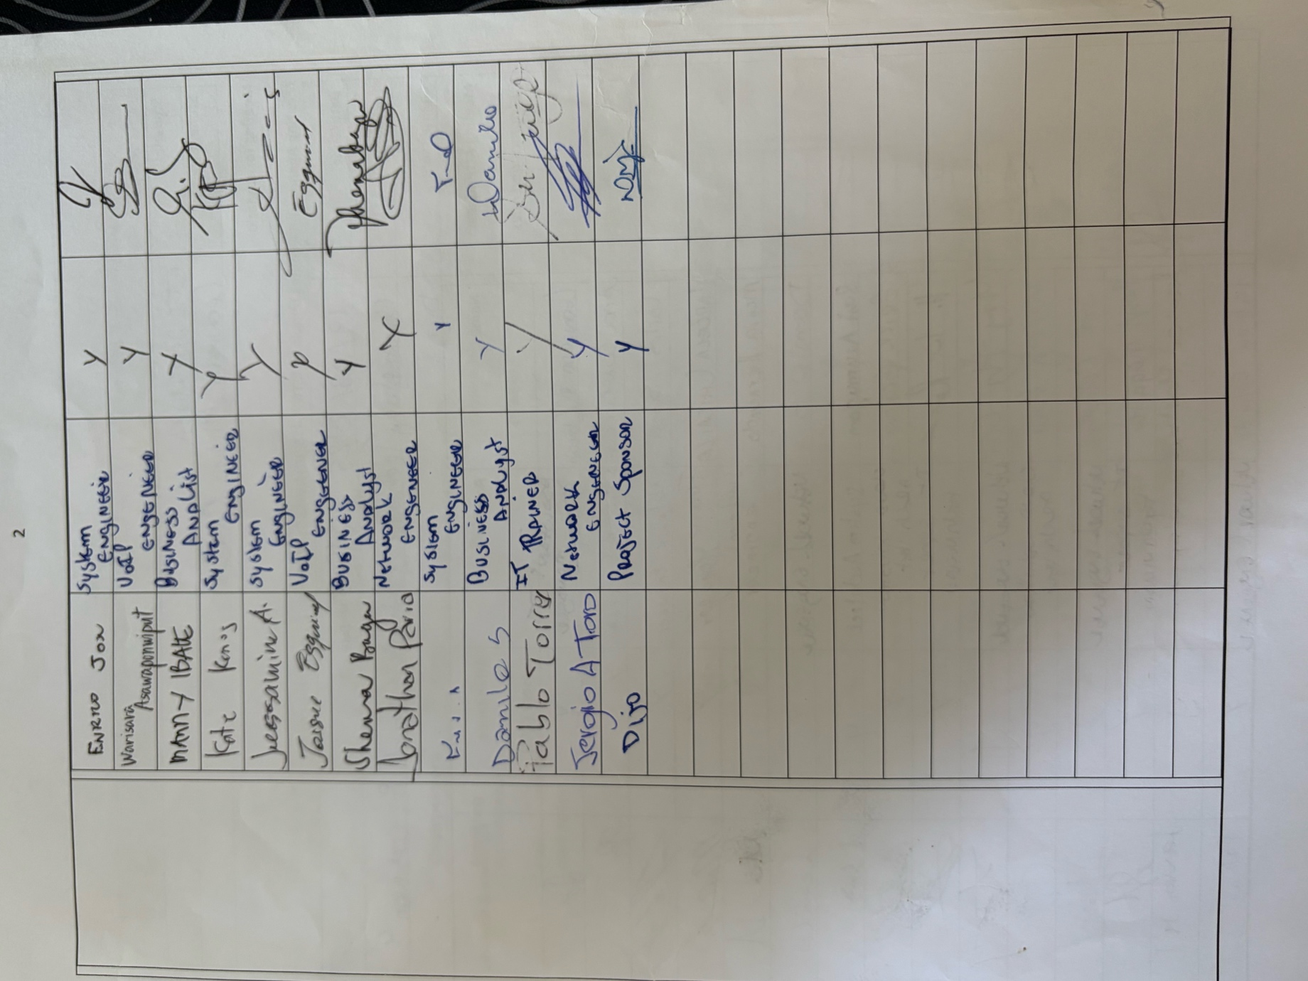  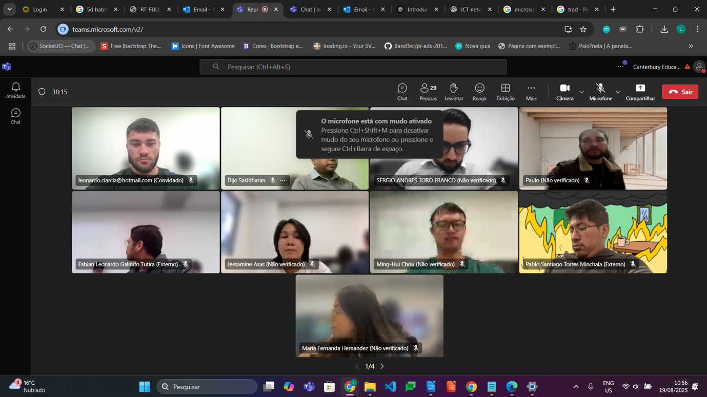  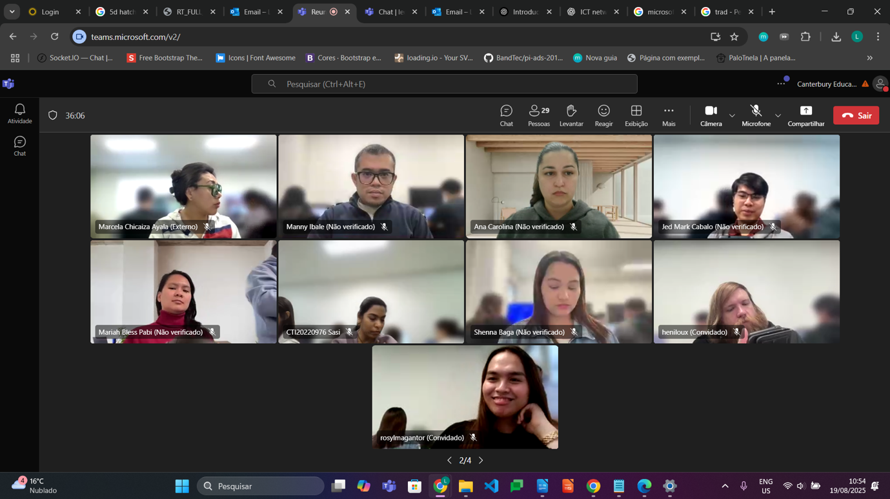  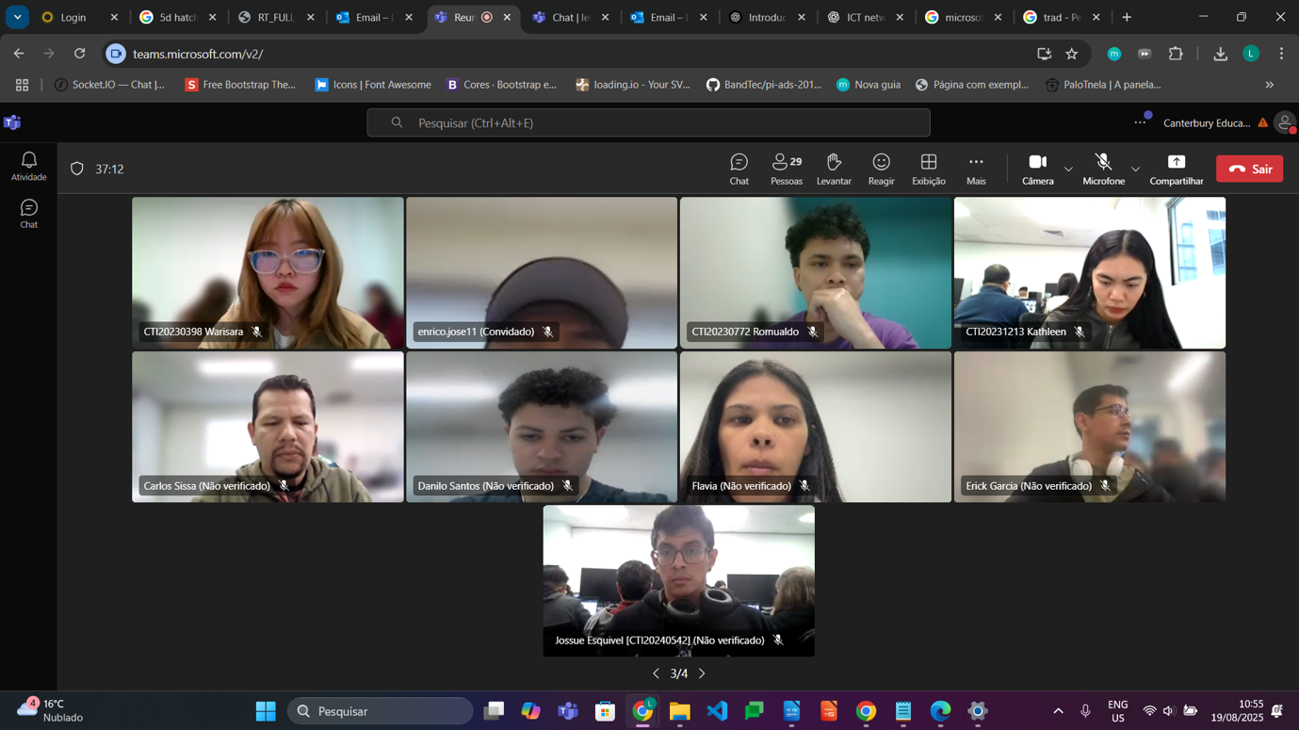  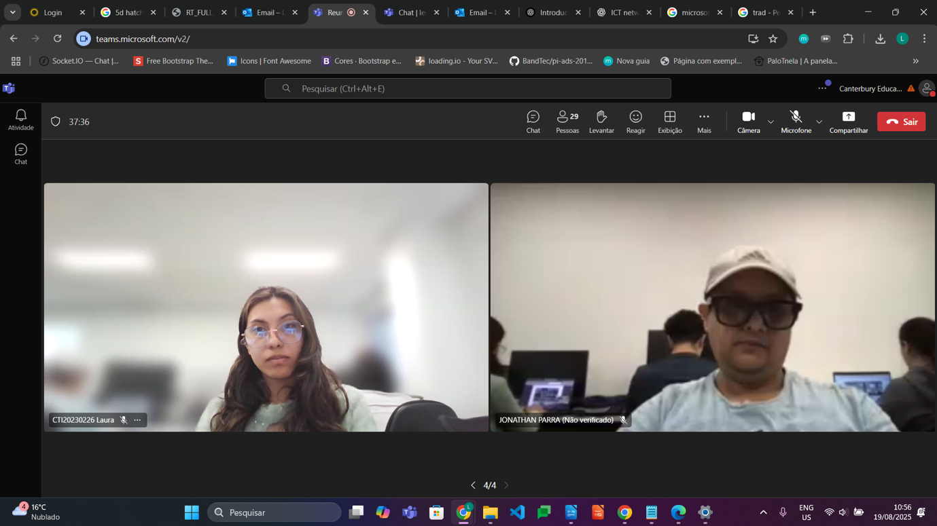
Agenda Item/Topic | Discussion/Activities/Outcomes |  | Action Officer | Target/  Due Date
Welcome | • welcomed the participants and explained that the meeting would review the proposed architecture for the A-Plus Institute network.  • The meeting focused on the final Network 3 design for the five-level Brisbane campus and its connection to the separate Rookwood campus.  • The participants were advised that the final outcome would support completion of the network architecture documentation and client approval. |  | Leonardo Ciarcia – Assistant IT Manager | At the beginning of the meeting
(Agenda item 1)  Topic?  - Network design scope, segmentation, network establishment and remote access | Motion moved by: Leonardo Ciarcia – Assistant IT Manager  Voting and Resolution: The motion was carried. The proposed project scope, VLAN segmentation and secure inter-campus connectivity were approved. |  | Assistant IT Manager and Network Architect | Within three business days after the meeting
  Details of discussion/activities (Points Discussed/ Activities completed) | Actions Suggested
  • Reviewed the project scope, business requirements, technical specifications and future growth objectives.  • Confirmed that the Brisbane campus consists of five levels: three existing levels and two new classroom levels.  • Reviewed the proposed hierarchical architecture with redundant core switching and separate access equipment for each level.  • Discussed network segmentation using VLANs for different departments, users, servers, wireless services and management functions.  • Confirmed the use of inter-VLAN routing to allow authorised communication between network segments.  • Reviewed the establishment of the Brisbane and Rookwood networks through the 3TTech service.  • Discussed secure remote and inter-campus access using a site-to-site IPsec VPN.  • Confirmed that guest access must remain separated from internal A-Plus Institute resources. | • Finalise the network scope and VLAN segmentation schedule.  • Document the Brisbane–Rookwood VPN and remote-access requirements.  • Confirm that access-control rules permit only authorised communication.
(Agenda item 2)  Topic?  - General networking components and preliminary network architecture | Motion moved by: Leonardo Ciarcia – Assistant IT Manage  Voting and Resolution: The motion was carried. The selected network components and preliminary architecture were approved for performance and cost evaluation. |  | Network Architect and Technical Specialist | Before performance evaluation begins
  Details of discussion/activities (Points Discussed/ Activities completed) | Actions Suggested
  • Reviewed the purpose of network interface cards, switches, routers, wireless access points, wireless controllers, servers, storage devices and transmission media.  • Discussed hubs as legacy shared-bandwidth devices and confirmed that managed switches are more suitable for the A-Plus Institute network.  • Reviewed the use of two Layer-3 core switches to provide routing, performance and redundancy.  • Confirmed the provision of one access switch and one managed wireless access point for each of the five Brisbane levels.  • Reviewed the dedicated server switch supporting DHCP, DNS, authentication, file, backup and monitoring services.  • Confirmed that 2911 routers would provide routing, NAT, VPN and edge access-control functions in the Packet Tracer design.  • Reviewed the physical and logical diagrams and confirmed that the server room is located on Existing Level 1. | • Finalise the physical and logical network architecture diagrams.  • Verify hardware and software compatibility with the project requirements.  • Document the purpose and connection of each major network component.
(Agenda item 3)  Topic?  - Network costs and anticipated performance | Motion moved by: Leonardo Ciarcia – Assistant IT Manage  Voting and Resolution: The motion was carried. The participants approved the cost categories and performance benchmarks for the final evaluation. |  | Procurement Officer, Network Architect and Project Manager | Before final design approval
  Details of discussion/activities (Points Discussed/ Activities completed) | Actions Suggested
  - Reviewed the expected cost categories, including routers, switches, access points, wireless controller, servers, storage, cabling, licences, labour, support and training.  - Discussed initial capital expenditure and ongoing operational costs.  - Compared supplier specifications, warranties, technical support, equipment capacity and expected service life.  - Reviewed current and future traffic demands associated with increased enrolments, additional devices and the two new classroom levels.  - Discussed performance benchmarks such as availability, bandwidth, latency, packet loss, wireless coverage, connection stability and recovery time.  - Confirmed that the design should support future expansion without creating unnecessary bottlenecks.  - Agreed that contingency funds should be available for unexpected cabling, equipment or implementation requirements. | • Obtain and compare current supplier quotations and technical specifications.  • Complete the predicted performance and cost evaluation report.  • Include an appropriate contingency allowance in the project budget.
(Agenda item 4)  Topic?  - Support, training, security and approval of the final architecture | Motion moved by: Leonardo Ciarcia – Assistant IT Manage  Voting and Resolution: The motion was carried. Network 3 was approved as the final architecture, subject to successful testing and formal client sign-off. |  | Assistant IT Manager, Network Administrator and Project Manager | Before final project handover
  Details of discussion/activities (Points Discussed/ Activities completed) | Actions Suggested
  - Identified support requirements for the core switches, access switches, routers, wireless controller, access points and server infrastructure.  - Discussed administrator training for VLAN management, wireless administration, DHCP, monitoring, backup and VPN troubleshooting.  - Reviewed user guidance for connecting to the correct staff, student or guest wireless service.  - Reviewed security controls, including VLAN separation, strong wireless encryption, authentication, router access-control lists, secure device administration, configuration backups and monitoring.  - Confirmed that router-based controls, NAT and VPN functions would be used in the Packet Tracer solution without adding a separate ASA firewall.  - Reviewed the final design against business requirements, performance expectations, costs and scalability.  - Confirmed the need to present the final documentation to the A-Plus Institute representative and obtain formal sign-off. | • Prepare technical support procedures and administrator training materials.  • Complete a final security and configuration review.  • Present the network architecture package and obtain client sign-off.
Summary | Overall Summary: The meeting reviewed the network design scope, segmentation, major components, remote connectivity, costs, performance, support, training and security. The final architecture supports five Brisbane levels, a separate Rookwood campus and secure connectivity through 3TTech.  Decision/s:  • Approve the hierarchical Network 3 architecture.  • Use redundant Layer-3 core switches.  • Implement VLAN segmentation and controlled inter-VLAN routing.  • Use a site-to-site IPsec VPN for inter-campus connectivity.  • Complete performance, cost, support and security documentation before sign-off.  Action/s if any:  • Finalise the architecture diagrams and component schedule.  • Complete the performance and cost evaluation report.  • Prepare support and training documentation.  • Complete the security review and obtain client approval. |  | Leonardo Matias Ciarcia | 22/06/2026
Next Meeting time/date | 30/09/2025 |  | Leonardo Matias Ciarcia | 19/08/2025
Meeting closed at: | 11:30AM |  | Leonardo Matias Ciarcia | 19/08/2025
Minutes are a true and accurate record of the meeting | Approved/confirmed by: (who?)  Dijo Sasidharan |  | Dijo | 19/08/2025
Signature of attendee 1: Dijo Sasidharan |  | Signature of attendee 3: Leonado Matias Ciarcia

